WELCOME TO ST. JOSEPH’S CHURCH, BRIGHOUSE

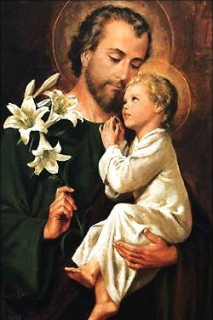
Parish Priest: Fr. Michael Hall Mobile 07525 419806
St. Joseph’s Presbytery, Martin Street, Brighouse HD6 1DA
Email – michael.hall@dioceseofleeds.org.uk
Parish Office 01484 712679 Hall Booking 07596 599084
Please note - the Parish Office phone will go to voicemail,
which is not checked more than once a week.
If your call is for Fr Michael, then please use his mobile number
Email - office.stjoseph.brighouse@dioceseofleeds.org.uk
Mission Committee: forum.stjoseph.brighouse@dioceseofleeds.org.uk
SAFEGUARDING Cathy Bird psr.cbird@dioceseofleeds.org.uk 07443482937
Parish Website www.stjosephschurchbrighouse.co.uk
MASS INTENTIONS 5th – 12th May 2024
 | Feast | St Joseph's, Brighouse | St Patrick's, Elland
Saturday | Vigil | 0930 Eddie France LD  1800 People of the Parishes | 1600 Gerry Wheatcroft int
Sunday  5th May | 6th SUNDAY of EASTER | 0830 Tom Hogan | 1030 Caroline Crosland and Arthur Wright
Monday |  | Sine populo K Mallaghan & family
Tuesday |  | 0930 Ben Lawlor
Wednesday |  | 0930 Int Paul and Anne Baker
Thursday | ASCENSION | 1440 School Mass – all welcome  1600 Reception of Jim Murphy  1900 Holy Souls | 1000 Roland Todd ann
Friday |  | 1330 Requiem Mass Jim Murphy
Saturday | Vigil | 0930 Albert Spratt Moore ann  1800 Donald and Andrew Gillespie | 1600 Joe McGrath LD
Sunday  12th May | 7th SUNDAY of EASTER | 0830 Stanisława Stepien | 1030 People of the parishes
At Brighouse, Holy Communion will be distributed at the Altar Rail.
Please stand or kneel as you wish; receive in the hand or the mouth as you wish;
stay as long as you want at the rail.
At Elland: “In your mouth before you move your feet”
ALL OF US TOGETHER

FAMILY-FRIENDLY MASSES
Children and families are welcome at all our Masses, but these special Masses are on:
26th May St Patrick’s 1030
30th June St Joseph’s 1600
29th September St Patrick’s 1030
COME AND SEE!
Next meeting Friday 10th May 7pm at St Patrick’s. Fr Josh Hilton:
“With Mary in the Upper Room”.

.
CRAFTERNOON!

ST PATRICK'S

Devotions
At St Patrick's the 7-day candle in front of St Anthony burns in praise & thanksgiving.
Bank Transfer details
HSBC sort code 40-27-15 and
account 01017411 in the name of "Diocese of Leeds St Patricks Roman Catholic Church Elland".
Mass intentions received since April 25th
Mary Philomena, Ursula Ferns, Frances Davidson
Morning Tea and Coffee
Do join us for a cuppa and a chat downstairs after the morning Mass.
Saturday evening readers' rota
Problems? Contact Eve on 07887 888363.
Children’s Liturgy Helpers
Our children’s liturgy runs every other week at the moment, but badly needs to recruit additional volunteers.
St Patrick’s Parish BBQ
after Mass on Sunday 16th June
Please pray for the sick and housebound of St Patrick's parish and elsewhere

Dolores Bolton, Fr P Nealon
Michael Connoley, Joe Cunningham,
Laura Eccles, Nuala McClarnon,
Sr Maria, Margaret Moses,
Kathleen O'Malley, Michael & Mary O'Malley, Francis Neary
Julia Neary, Karen Pettie,
Joan Rushworth, Margaret Vickers, Gerry Wheatcroft, Arnold Whitacker,
All those in Overgate Hospice
Please remember too all those members of the community who are doing so much to keep us all supplied - delivering our medicines and our goods, as well as all those working in our Hospitals and Hospices
Please let Fr Michael know if there are any more names to be added to this list
ST JOSEPH'S

Devotions
St Joseph's candle burns for our parish school.
S.V.P MEETINGS
The St Vincent de Paul group meets every other Tuesday at 7pm. If there is an evening Mass the meeting will start immediately after. Anyone interested would be very welcome to come along. More details of meeting dates on the Hall notice board.
Tea and Toast
Join us after the 8.30 Mass! A great opportunity to catch up with old friends and new.
Friday Soup lunch
After the 12 noon Mass
Bank Transfer details
HSBC sort code 40-27-15 and account 91314777 in the name of "Diocese of Leeds St Josephs Roman Catholic Church Brighouse".
Mass intentions received since April 25th:
Jim Green, Emmie Kennedy, Michael Clark, Liz Crawshaw, Mabel Swain, Ben Lawlor, Margaret Kelly, Kathleen Comaskey
Common Good Journey
7.30pm Wednesday nights in the Lower Parish Hall. Come and find out what you’ve been missing!
Brighouse Parish BBQ
We are holding a barbeque after the Family Mass at St Joseph’s on Sunday June 30th. This will last from 5 – 7pm.
We are looking for people to plan and cook this BBQ! Please contact Fr Michael or the Mission Committee.
Walsingham Pilgrimage September
The Parish Mission Committee is asking for expressions of interest for a pilgrimage to the shrine of Our Lady in Walsingham, Norfolk.
We would be staying overnight on the Friday in or near Walsingham, attending the pilgrimage on the Saturday and travelling back that evening. Travel and accommodation costs to be determined based on numbers and requirements
If you are interested, please sign up on the sheets in the porches at church giving your name, a contact telephone number and stating how many people will be in your party. The closing date is next Thursday 9th May.

Please pray for the sick and the housebound St Joseph's parish
Brenda and Keith Bown and family,
Trevor and Gerard Chatburn,
Jack Dennison, Gordon Doyle
Pat Evans, Otylia Gregorczyk,
Pamela Lawson, Kevin Lawson,
Kathleen McEvoy,
Hugh & Molly McGeady,
Eileen Pugh, Joan Rushworth,
Margaret Rayner, Julie Simpson,
Nowel Turpin, Emma Worth,
Doreen Walker
- If you want someone's name to be added, please text or email Fr M

Asking Our Lady's help
During Eastertide our Marian antiphon after Mass is the lovely "Regina Caeli"
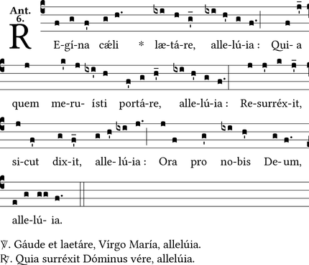
Joy to thee, O Queen of Heaven, Alleluia
He whom thou wast meet to bear, Alleluia
As he promised, hath arisen, Alleluia
Pour for us to him thy prayer, Alleluia
V:/ Rejoice and be glad,
O Virgin Mary, alleluia.
R:/ For the Lord has truly risen, alleluia.
Let us pray.
O God, who gave joy to the world through the resurrection of Thy Son, our Lord Jesus Christ,
grant we beseech Thee,
that through the intercession
of the Virgin Mary, His Mother, we may obtain the joys of everlasting life. Through the same Christ our Lord. Amen.
May devotions in our schools
How lovely to see the boys and girls of our schools honouring Our Lady at the beginning of her Month of May

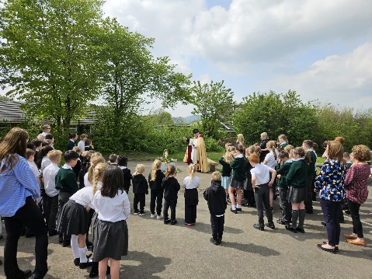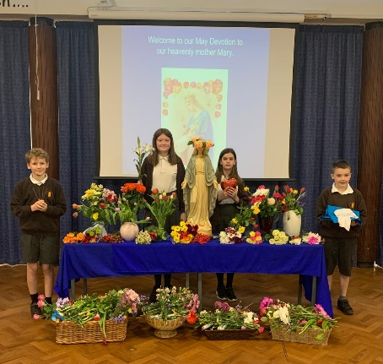
Congratulations to Claire Bonner on her appointment last week as the new headteacher of St Joseph’s Academy, and repeated congratulations to Alex Hudson-Crook, moving on from St Patrick’s to Sacred Heart, Sowerby. She will be greatly missed.

